**Shehab Hasan – 2632766 – 10/17/2020**

**IST 634 Assignment 2 – Chapter 7 exercises**

Do the following from the end of chapter 7: 7.5a, 7.5b, 7.7a, 7.7b, 7.7c, 7.8a, 7.8b, 7.8d.

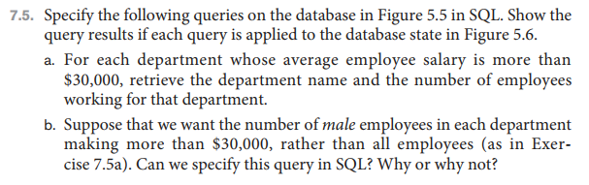

The innermost nested select gets average salary by department.

The 2nd nested select filters for average salaries above 30000.

The outer select counts the employees.

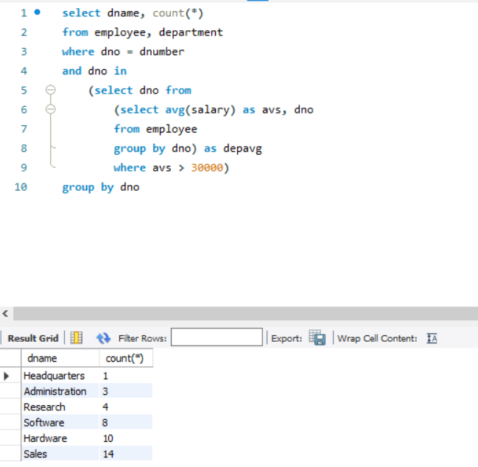

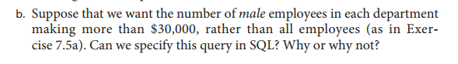

Yes, by adding a “Sex = ‘M’” in the where clause

